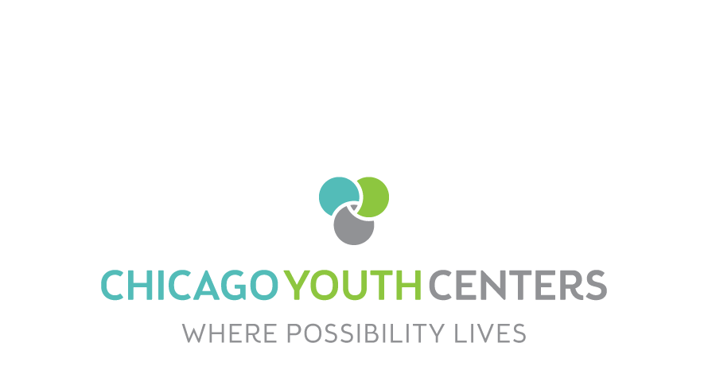

chicago youth Centers Sidney epstein Center

LOCAL Advisory Board Membership Application

Applicant Information

Name: | Email: |  | Phone:
Current address:
City: | State: |  | ZIP Code:

Employment Information
Current employer:
Does your employer match funds? |  |  | Please circle yes no
Retired |  |  | Please circle yes no

Emergency Contact
Name
Relationship |  |  | Phone:

membership and Associations (professional, Board, SOCIAL, religious, honorary, etc)
Name:
Name:

References
Name: Address: |  |  | Phone:
1)
2)
3)

Areas of Interest (mark your areas of interest)
Fundraising | Programs |  | Mentoring
Finance | Community Engagement |  | Volunteer
Membership | Member Engagement |  | Other

Children Enrolled in CYC Programs (if any)
Name Age |  | Name Age
Name Age |  | Name Age
Please send/submit your application to:
Attention: Clarence Hogan, clarence.hogan@chicagoyouthcenters.org
3415 W. 13th Place Chicago, IL 60623 (773) 762-5655
Signature of applicant: |  |  | Date:

Narrative

Please take a moment to tell us briefly about yourself and what unique talents you can bring to the Chicago Youth Centers-Sidney Epstein Youth Center:

